Dr. Carl W. Thompson

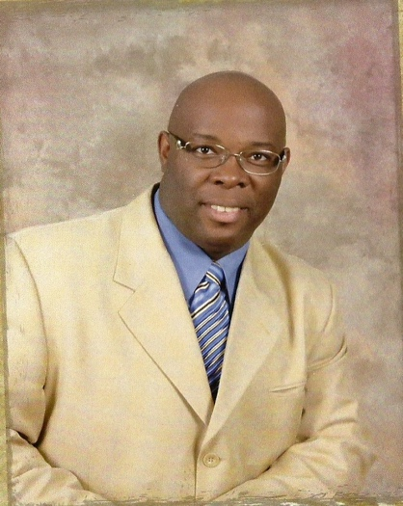
Dr. Thompson was born and raised in Louise, Mississippi. Dr. Thompson has been married to his wife Peggy Thompson since June 26 of 1999. This union has blended two beautiful daughters, three handsome sons, and five adorable grandchildren.

At the age of thirty-five (35), Dr. Thompson felt the call to preach and teach the Gospel of Jesus Christ on his life and medical retired from the Department of Veterans Affairs in Jackson, Mississippi in 2002. At the age of thirty-six (36) he answered his call to preach/teach, and was licensed and ordained by Pastor Lazarus Taylor III of Greater Nazareth M.B. Church in 2003. Dr. Thompson served as Senior Pastor of Pleasant Valley Missionary Baptist Church in Inverness, Mississippi for seven years. Under the unction and leading of the Holy Spirit he was lead to move here to Indianapolis where he now serves as Senior Pastor of New Mission Baptist Church.

Dr. Thompson received his Bachelor, Master, and Doctorate Degree of Theology from Trinity Theological Seminary in Bentonia, Mississippi where he served as Dean of Academics, Correspondence Director, Online Class Instructor/Director, Class Professor and a member of the Board of Director for TTS. Also, Dr. Thompson received his certification as an International Christian Chaplain through the International Federation of Christian Chaplains Incorporation and is currently working on becoming a certified Chaplain through the Sheriffs Chaplaincy Conference accredited by the ILEA. Dr. Thompson served two years as a Hospice Chaplain for St. John’s & St. Anthony Hospice and Palliative Care in Ruleville, Mississippi. Dr. Thompson is now serving as a volunteer police chaplain for the Cumberland Police Department and Lawrence Police Department.

