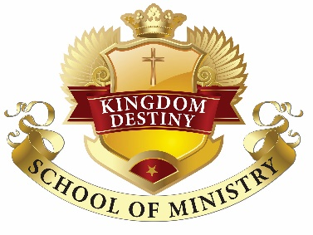

Kingdom Destiny School of Ministry
Beginners Class

Course Outline and Description

Fall Session
- Kingdom Leadership – This class will introduce the basic skills needed and/or required to be an effective leader, not only in the Kingdom of God, but in every aspect of life.

- Christ our Role Model/Standard – This class outlines how Christ lived while on earth and the examples that were set for today’s Christians, and how Christians are to pattern their daily lives after Christ.

- 7 Steps to Bible Skills - This class teaches how to study and learn the skills necessary to understand the Bible better. The class outlines of the books of the Bible and their arrangement, the history of how the Bible got to be the Bible we use today, how to study the bible and use biblical resources.

Winter Session
- Biblical Hermeneutics - This class covers the science of how to properly interpret, understand, and apply the Word of God. Historical interpretation refers to understanding the culture, background and situation which prompted the text. Biblical hermeneutics teaches how to properly apply scripture.

- Five Fold Ministry – This class covers the offices or roles of leadership in the church and the breakdown of each anointing gift, the biblical definition, the qualifications and the purpose of each role.

Spring Session
- Seven Steps of Biblical Salvation – In this lesson we will study Soteriology, which is the theology dealing with salvation, especially as effected by Jesus Christ. This lesson lists seven of God’s chosen “means of grace”, and is intended to be a quick reference and teaching tool. In this lesson, we have compiled pertinent portions of the pure Word of God to show how God saves us by His grace. (When the truth of salvation by grace is better understood, the doctrine of easy believism loses its siren appeal.)

- Denomination Comparison – This class outlines and compares the differences taught in various Christian denominations, where they originated from, and what they believe on different topics i.e., God, the Trinity, Jesus, the scriptures, Baptism, and salvation.

- Pulpit Etiquette, Protocol, and Ethics – In this class, we present ministerial etiquette on how you are to handle yourself as a minister (on and off the pulpit) and Pastoral duties, protocol for performing marriage and funeral services. You will be introduced to sacred scriptures that you will be able to use as reference during ministry.

- Introduction to Biblical Counseling – This class introduces the basic skills necessary to provide spiritual counseling, along with the protocol, confidentiality and legal requirements associated with Christian counseling.

